Setting up Flask on Apache Windows

Prerequisites:

- Apache from apache lounge: <https://www.apachelounge.com/download/>

- Visual C++ Redistributable for Visual Studio 2015-2019: <https://www.apachelounge.com/download/>

- Visual C++ Build tools: <https://visualstudio.microsoft.com/visual-cpp-build-tools/>

Step 1:

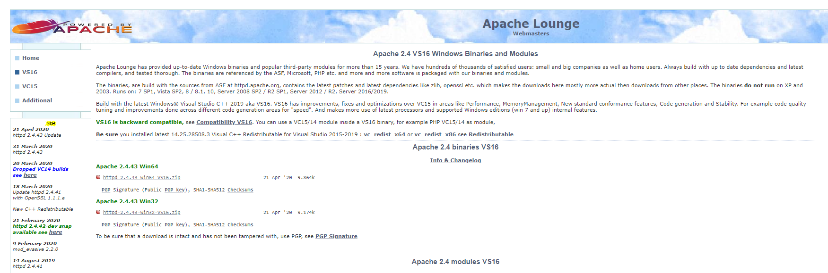

Download this two links

Step 2:

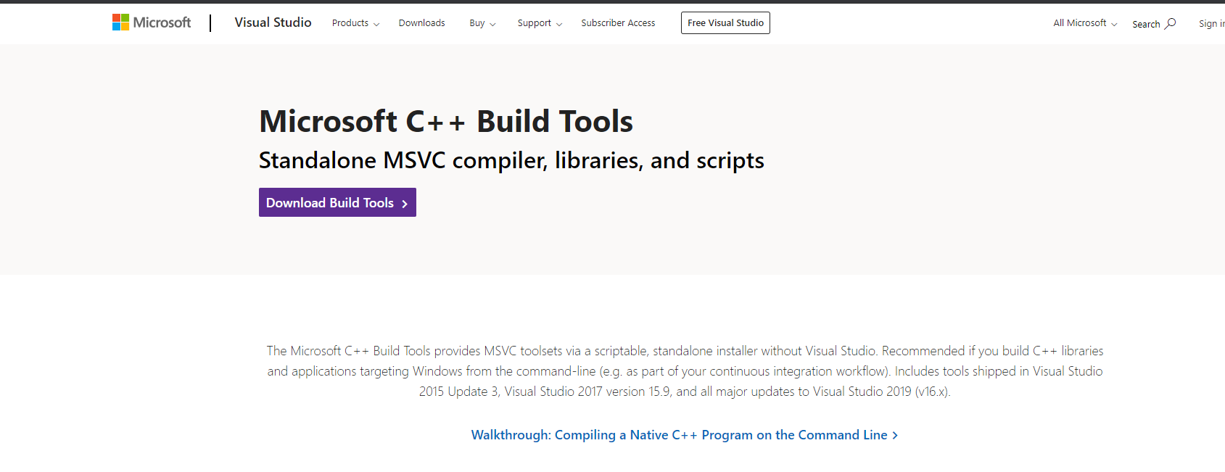

Step 3:  
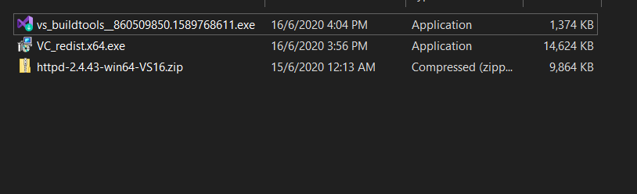

- Run the first two applications

- Extract httpd-2.4.43-win64-VS16 into C:

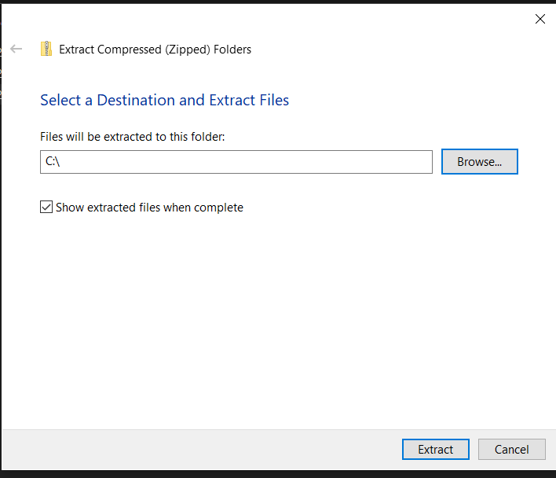

Step 4:  
Open cmd as administrator

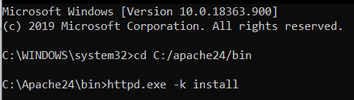

Run these commands

In services, apache24 should be there

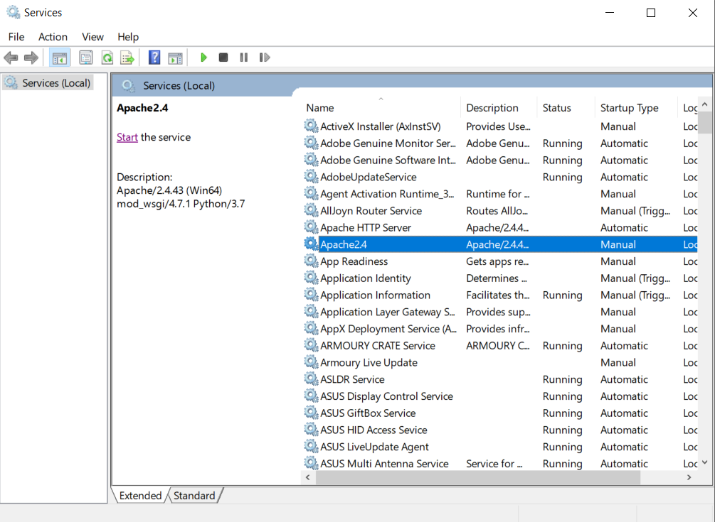

Step 6:

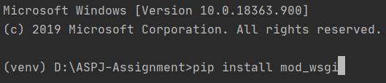

Install mod_wsgi in your **venv.**

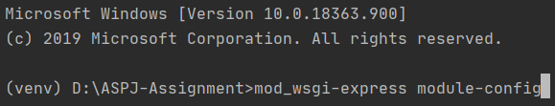

Run the above command and you should get the following output



Step 7:

Open C:\Apache24\conf\httpd.conf

Look for the end of the load modules and insert the output below them

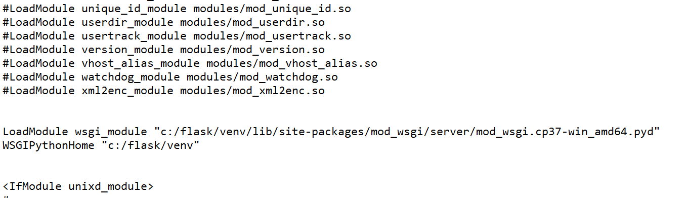

Step 8:  
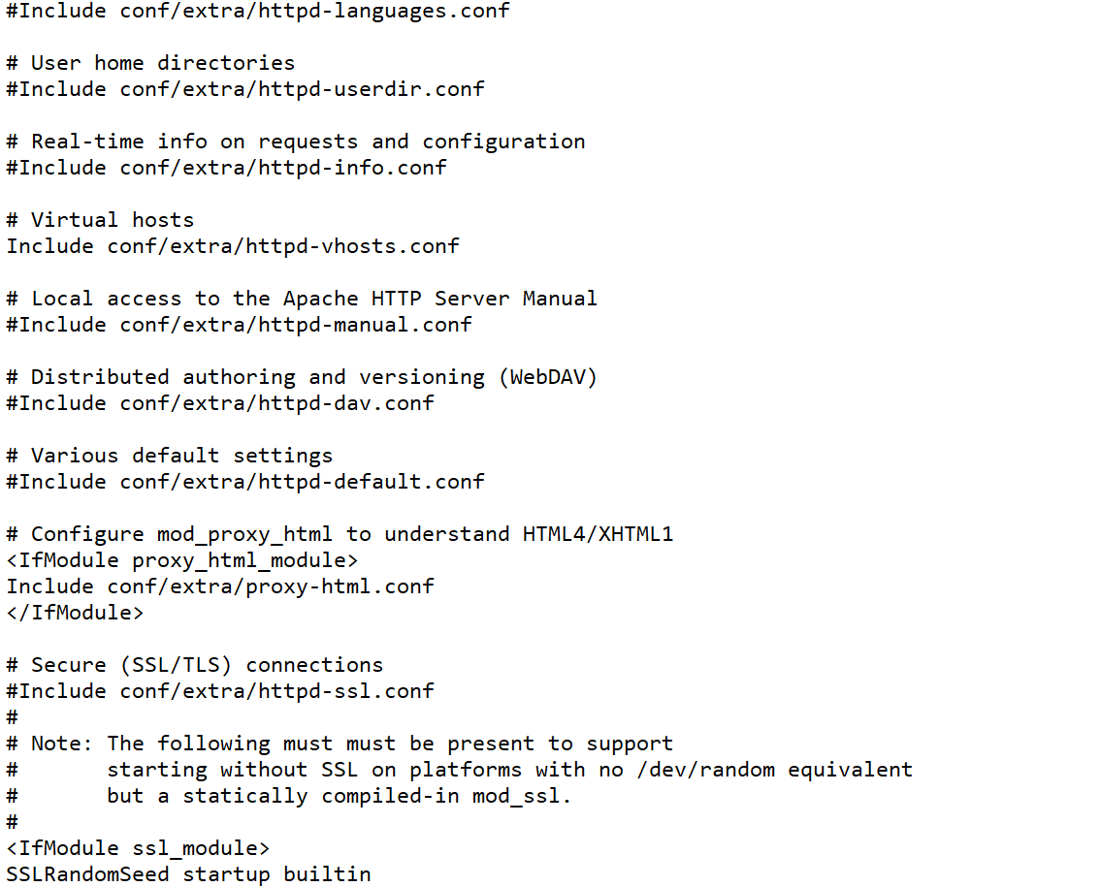

Uncomment include conf/extra/httpd-vhosts.conf

Step 9:  
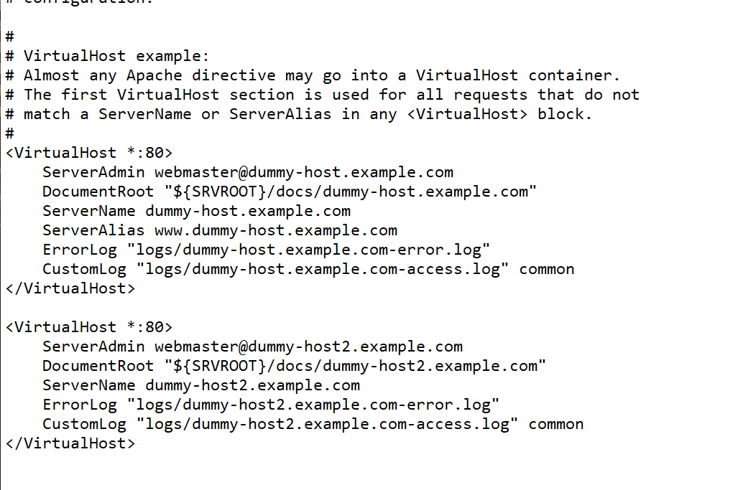

Delete the two <VirtualHost*:80> and insert the following

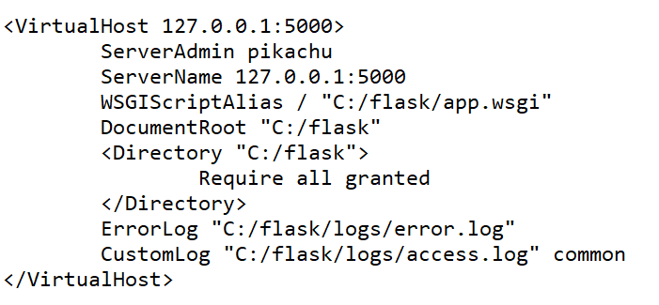

<VirtualHost x.x.x.x:x> => The ip address: port number of your flask application

ServerAdmin => The name displayed for when an internal server error/ any server error? Occurs

ServerName => Should be the same as the VirtualHost, unless you have a domain name

WSGIScriptAlias => where the wsgi file is located, refer to step 10 on how to create it

DocumentRoot => where the flask application folder is located

<Directory “xxx”> => same as DocumentRoot

ErrorLog => where the apache server will write the errors if anything occurs in the flask app

CustomLog => where the apache server will write the accesses in the flask app

Step 10:

Create the wsgi configuration file in the same level as your flask app

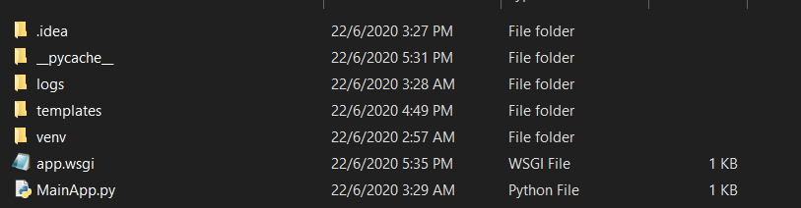

Write this inside the file, you can use pycharm to do this

Note that “C:/flask” should be where your virtual environment is located

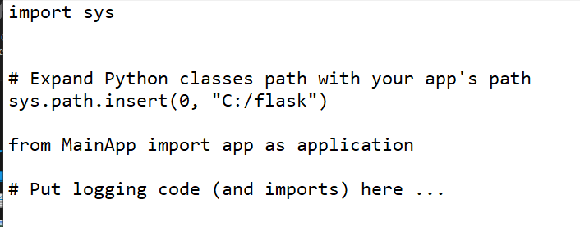

Step 11*: (Not the most elegant solution to this, will update if better one comes along)

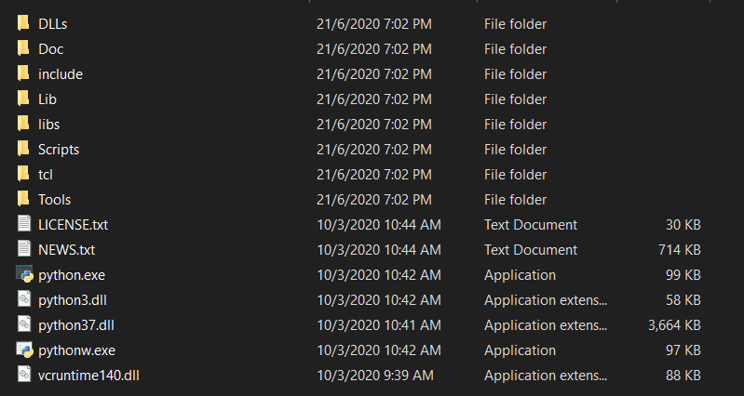

Copy the three following files into your **venv.** Skip any duplicates.

Step 12:  
If you are using any port other than port 80…

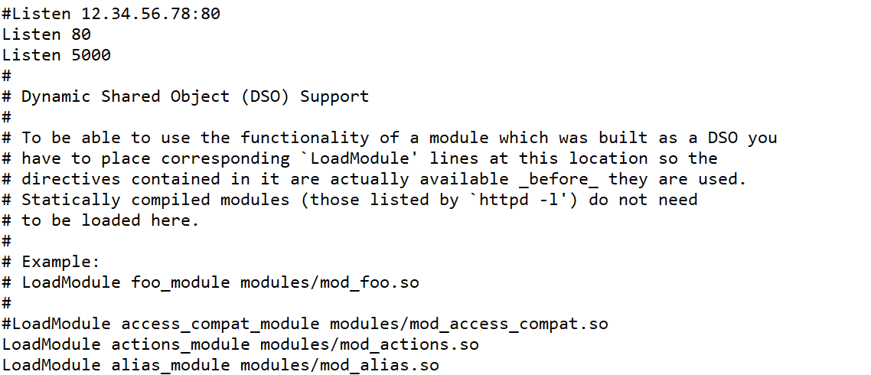

Add Listen <port number here> into the C:\Apache24\conf\httpd.conf.

Final Step:

Start the service, fingers crossed

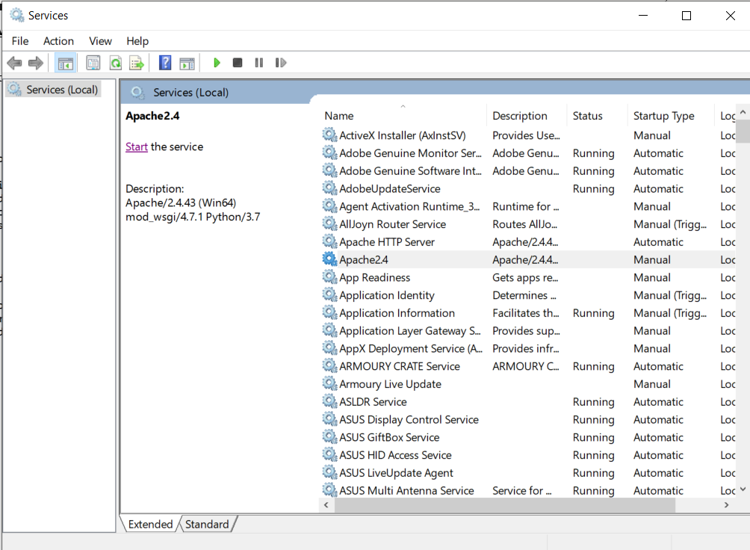

If any errors occur when starting up the server -> C:\Apache24\logs\error.log

If any errors occur in your flask app -> C:/Apache24/conf/extra/httpd-vhosts.conf -> the location of your ErrorLog that you specified

